1. Compile and Migrate the application to the development environment

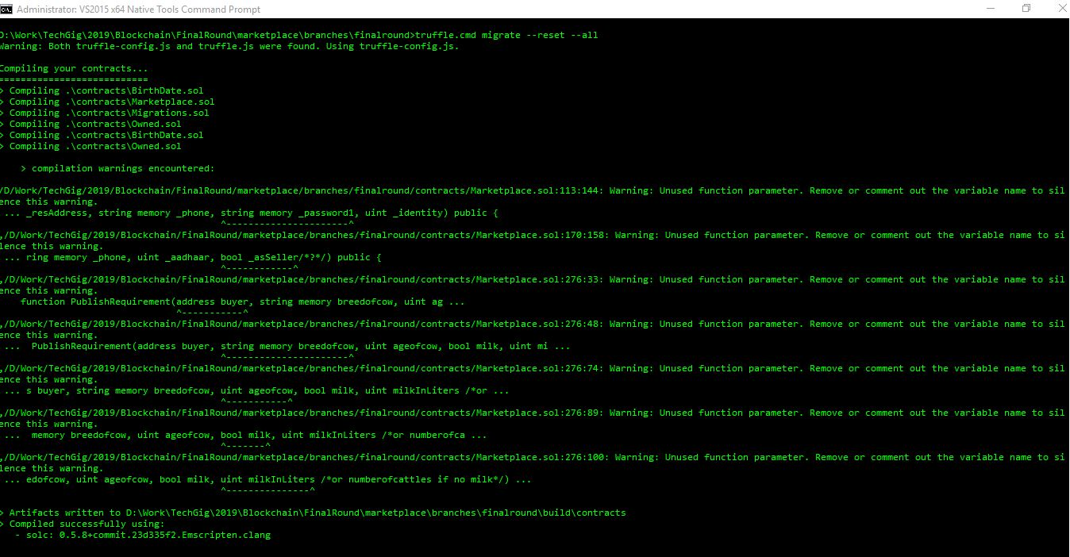

1. Compile and Migrate – part 2

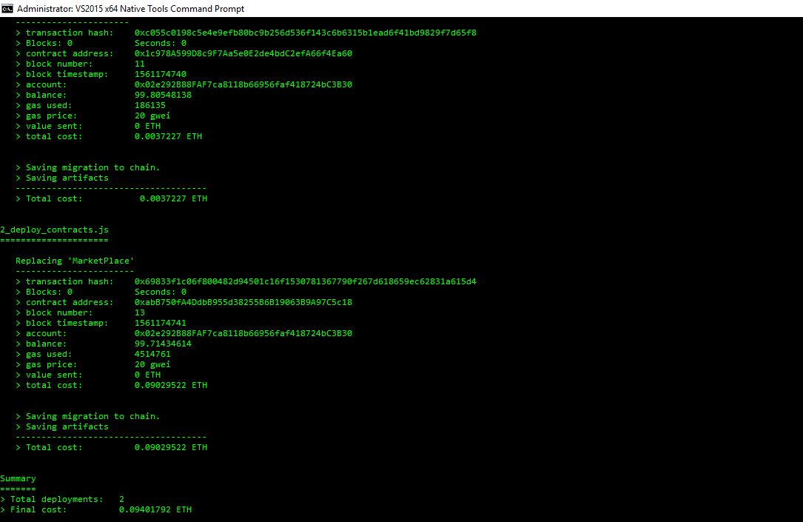

1. Start Ganache - the in-memory blockchain network

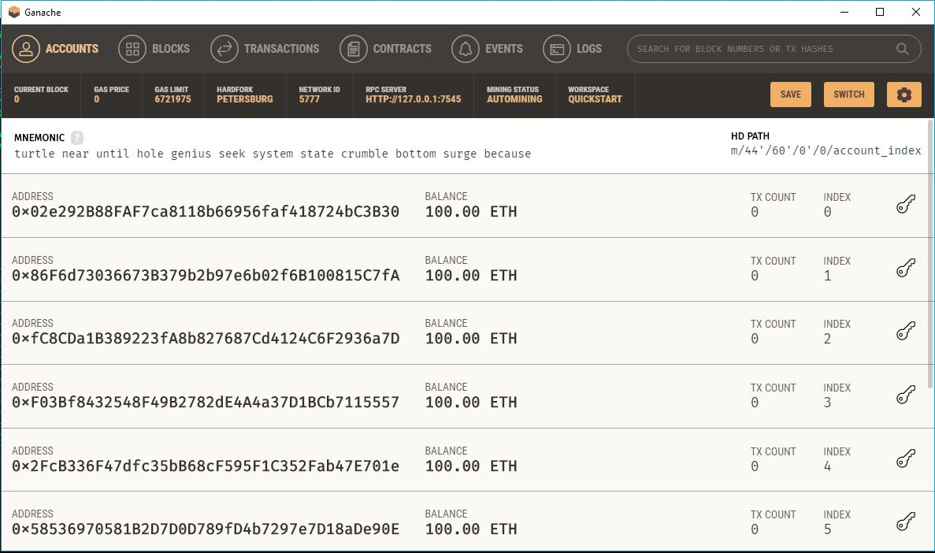

1. Run the Blockchain Network

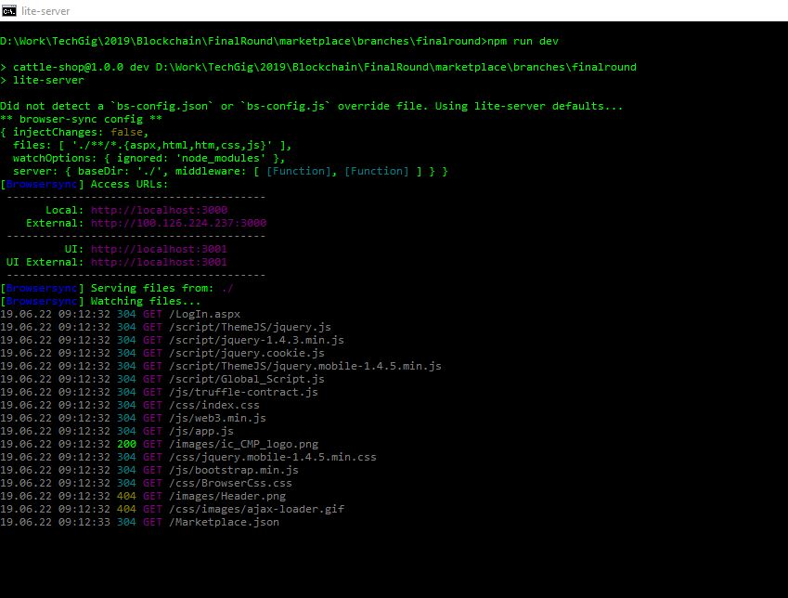

1. Login to the application or Create new user account

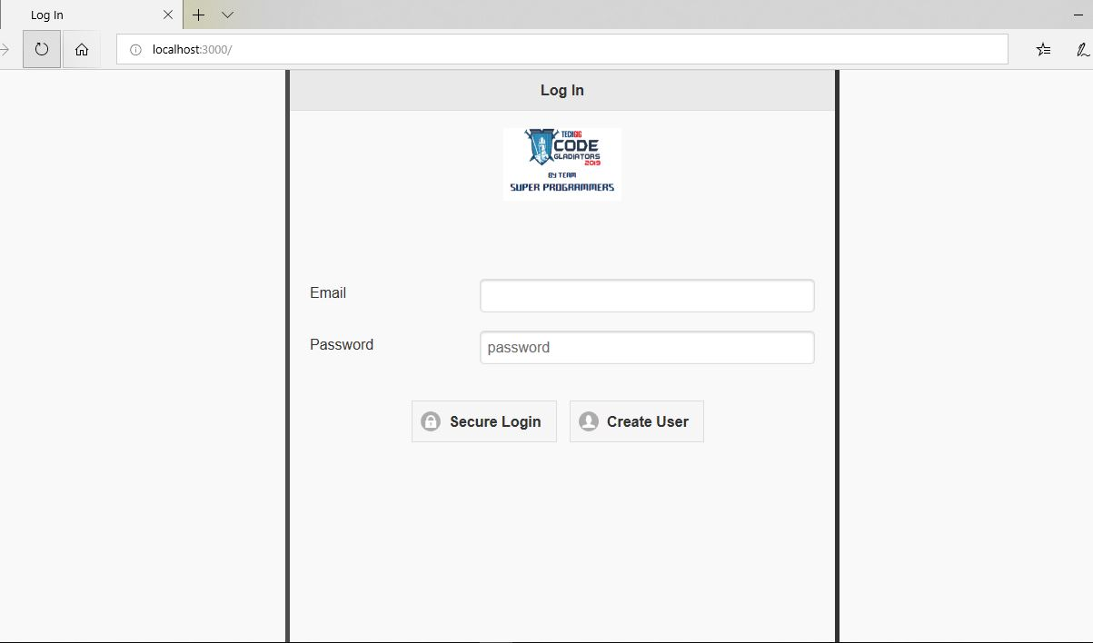

1. Create New User Account

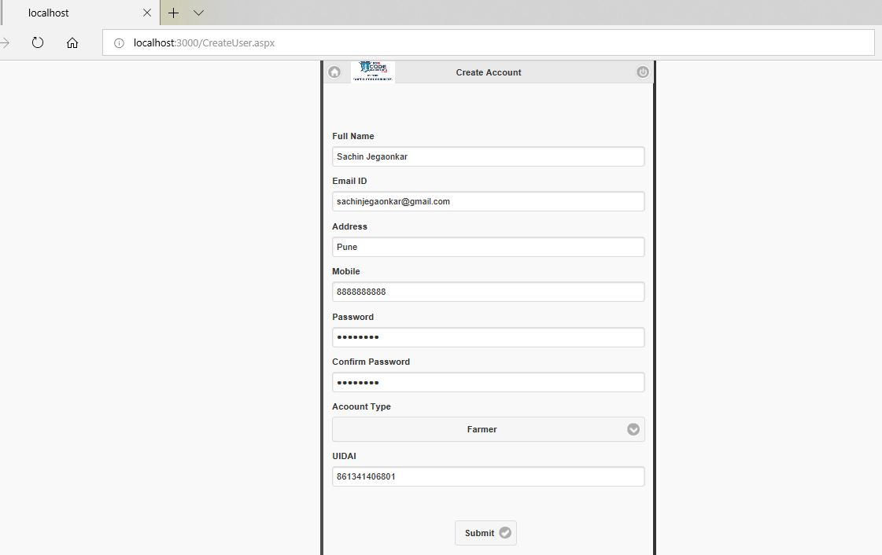

1. Blockchain Transaction - After doing Submit

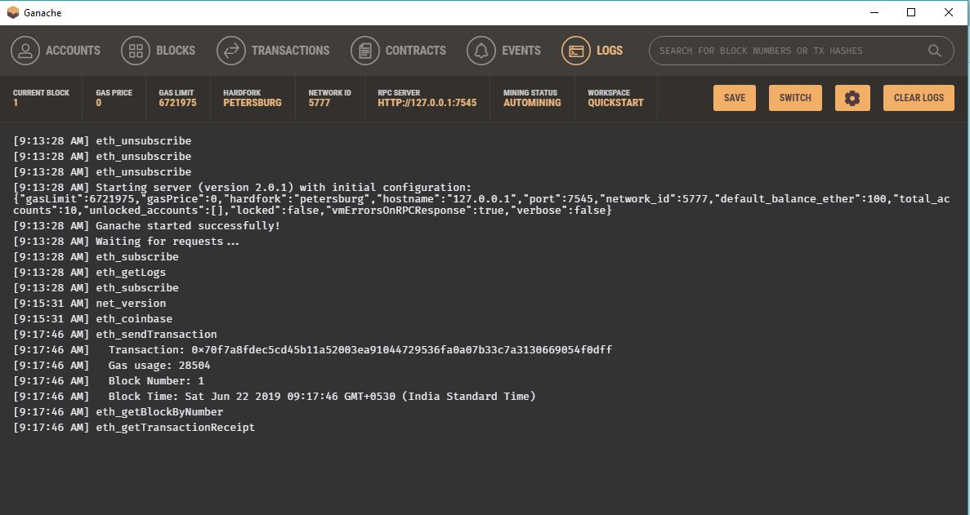

1. The Blockchain Transaction Details - Create New User

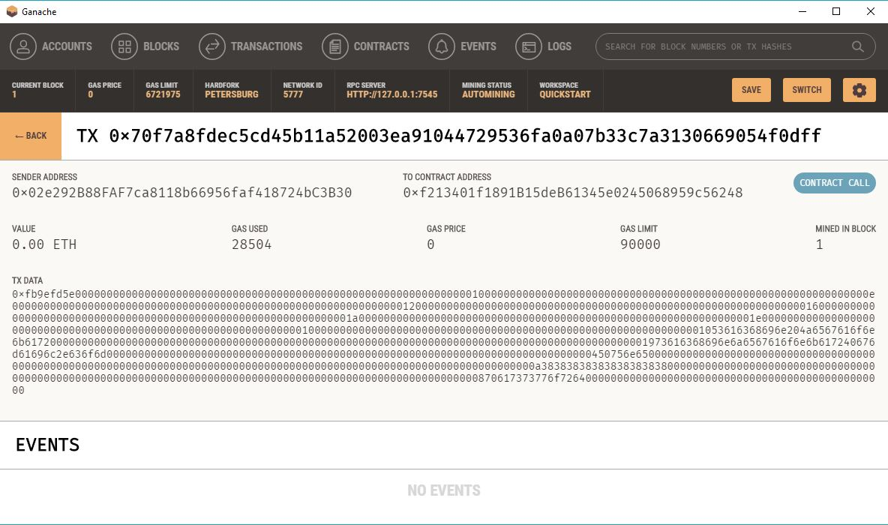

1. Application’s Home Screen

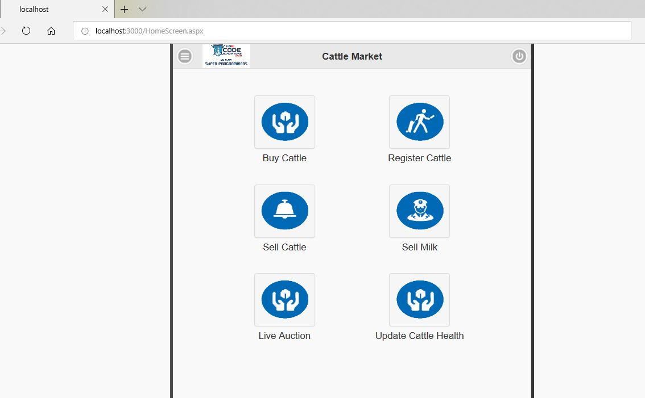

1. Register Cattle – Screen

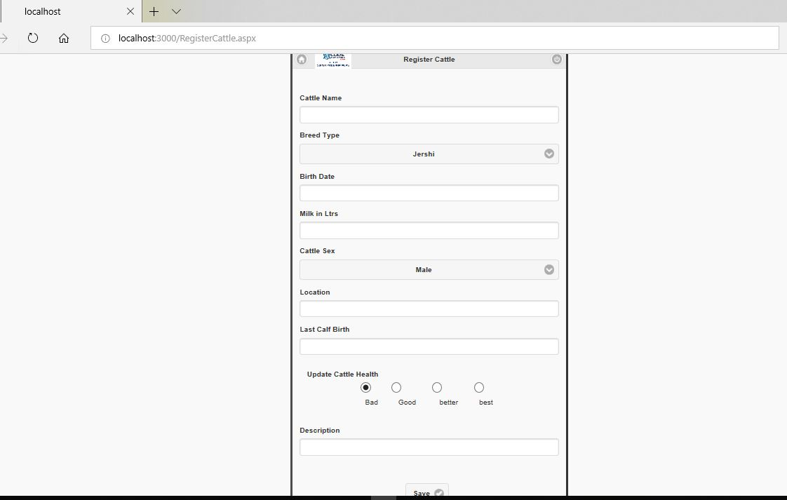

1. Sell Cattle – Screen

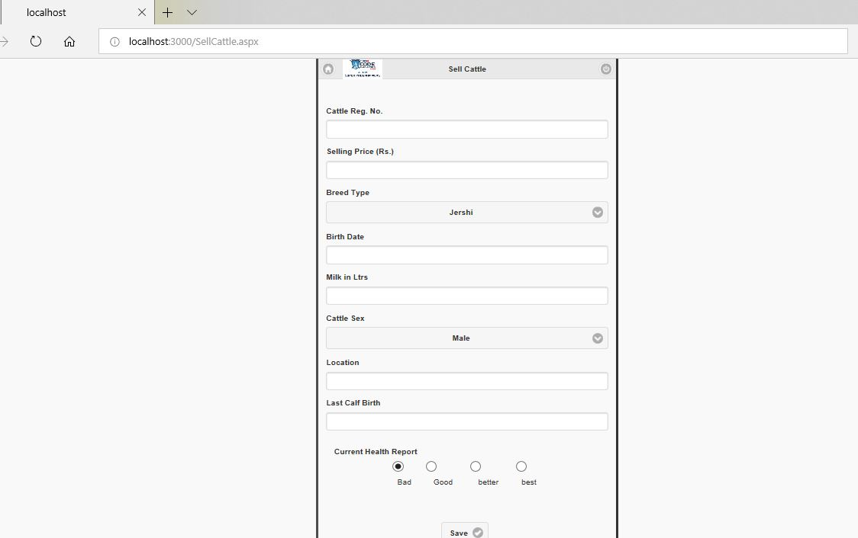

1. Using Remix IDE - The Smart Contract Compilation

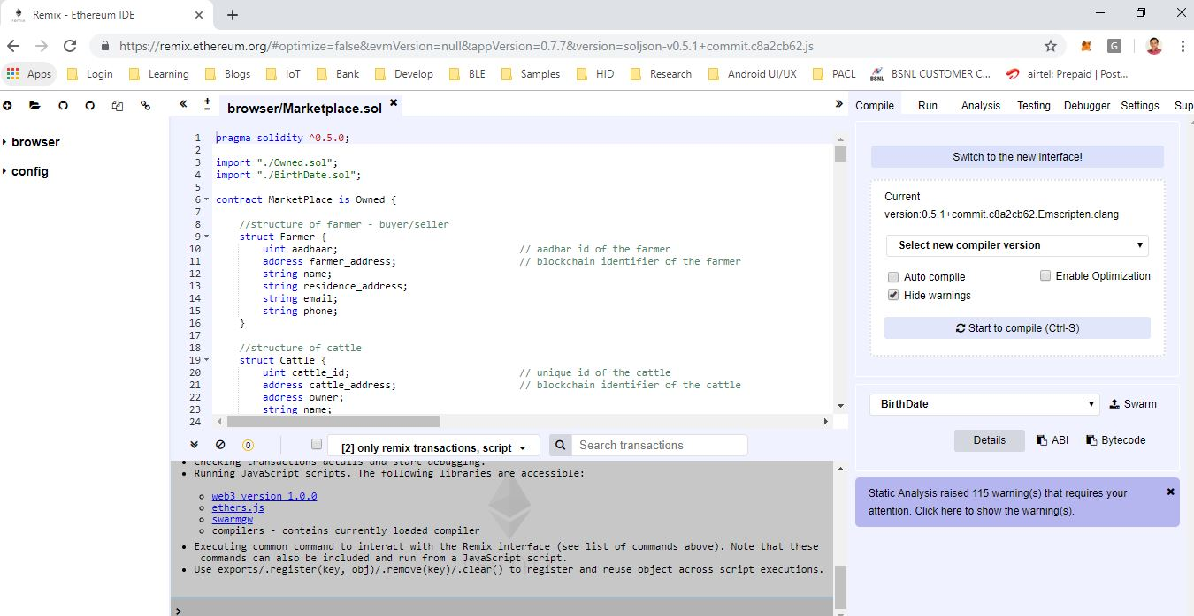

1. Deploy Smart Contract on Ethereum Network

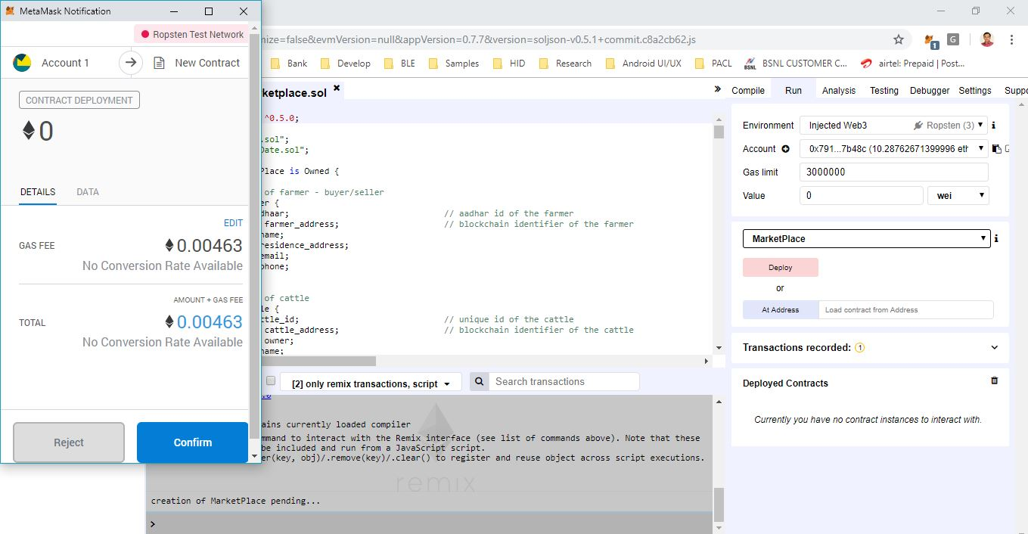

1. Metamask - Transaction Confirmed Notification

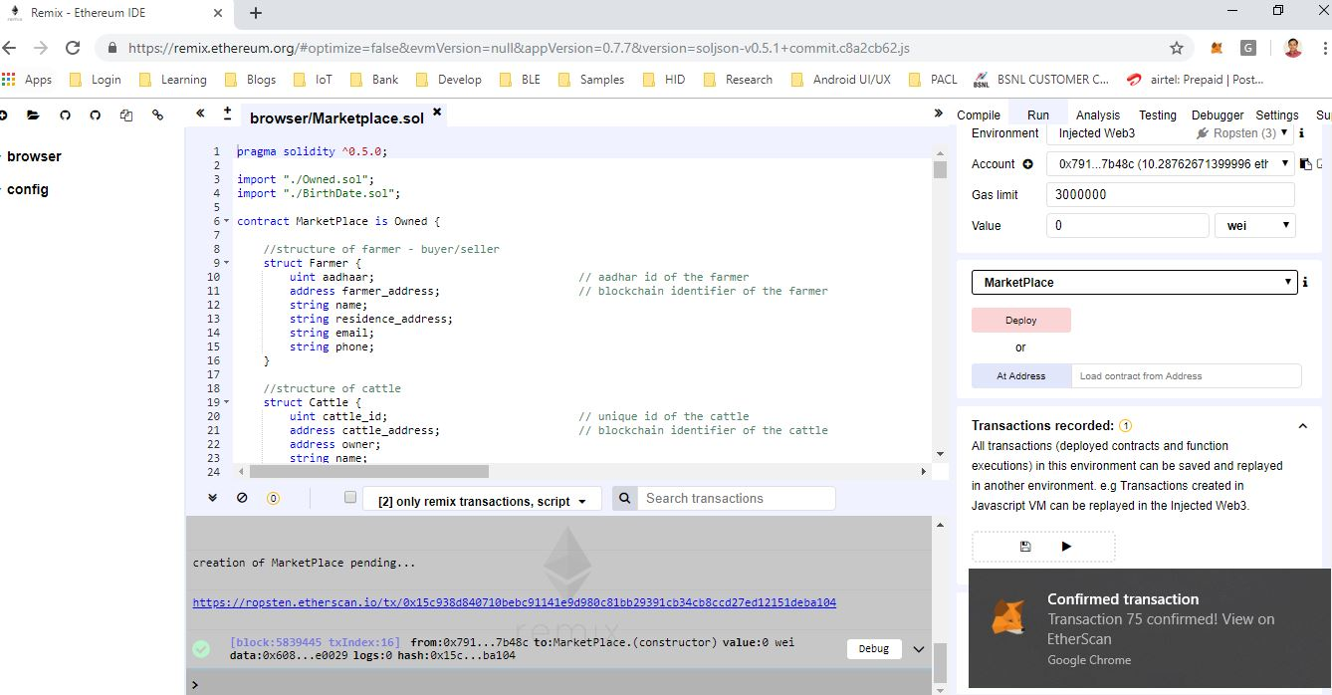

1. The Transaction Details - For Smart Contract Creation

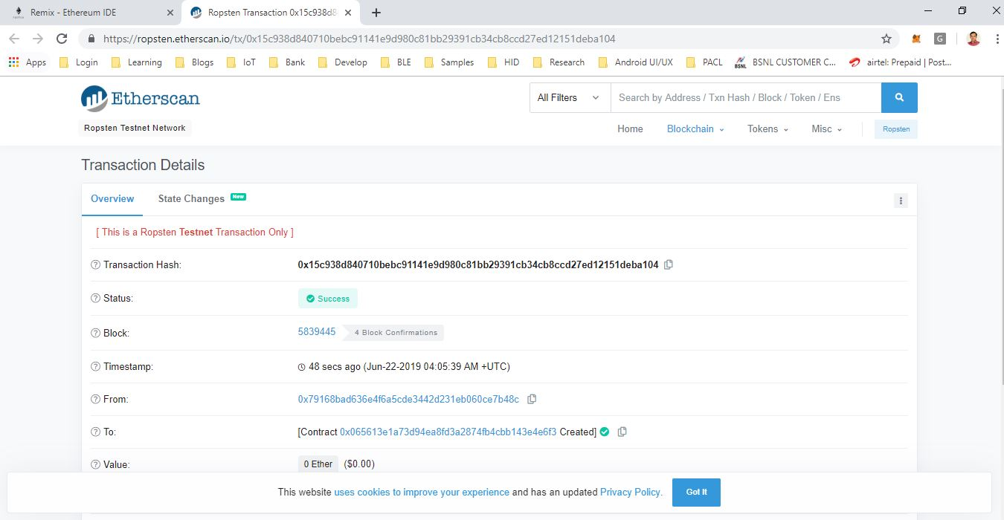

1. The Deployed Smart Contract Interface

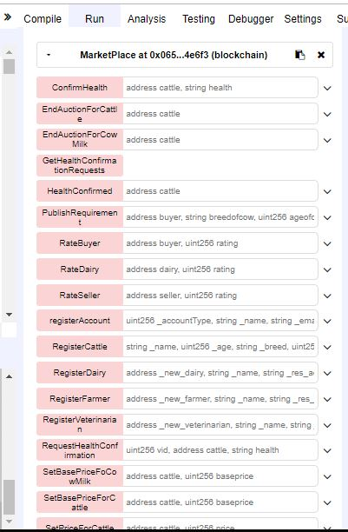

1. Transact to MarketPlace.RegisterCattle pending...

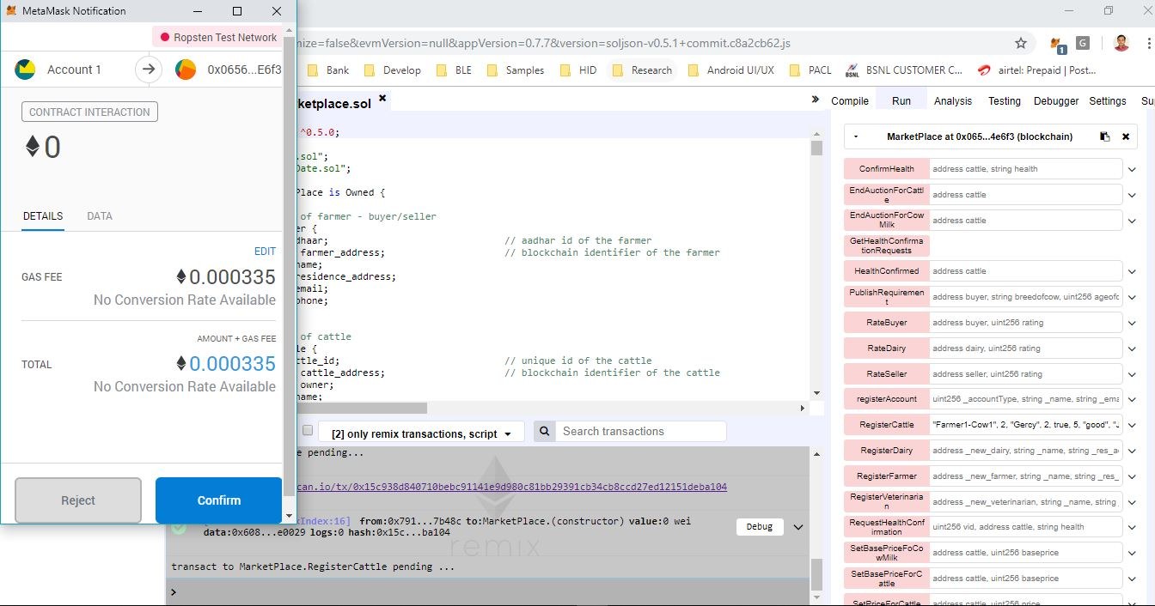

1. Metamask Transaction Complete Notification

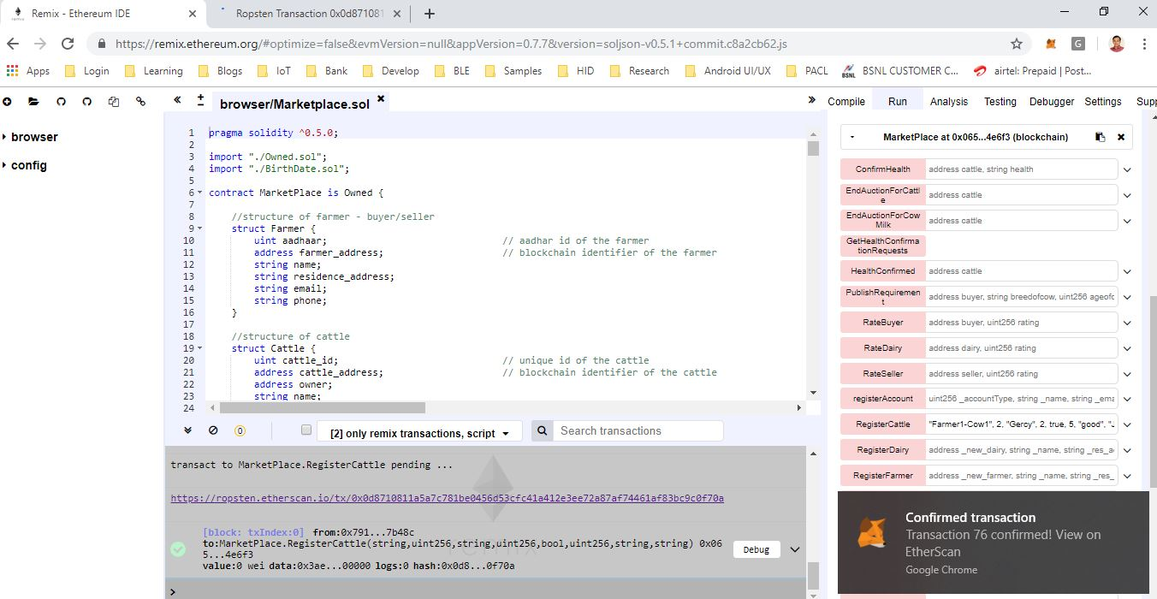

1. The Transaction Details

